*Florida International University*

*School of Computing and Information Sciences*

Software Engineering Focus

Final Deliverable

Project Title:

Learning with Virtual Reality 5.0

**Team Members:** Roger Boza, Jerry Pujals

**Product Owner(s)**: Shahin Vassigh

**Mentor(s)**: Shahin Vassigh

**Instructor**: Masoud Sadjadi

The MIT License (MIT)

Copyright (c) *2016 Florida International University*

Permission is hereby granted, free of charge, to any person obtaining a copy of this software and associated documentation files (the "Software"), to deal in the Software without restriction, including without limitation the rights to use, copy, modify, merge, publish, distribute, sublicense, and/or sell copies of the Software, and to permit persons to whom the Software is furnished to do so, subject to the following conditions:

The above copyright notice and this permission notice shall be included in all copies or substantial portions of the Software.

THE SOFTWARE IS PROVIDED "AS IS", WITHOUT WARRANTY OF ANY KIND, EXPRESS OR IMPLIED, INCLUDING BUT NOT LIMITED TO THE WARRANTIES OF MERCHANTABILITY, FITNESS FOR A PARTICULAR PURPOSE AND NONINFRINGEMENT. IN NO EVENT SHALL THE AUTHORS OR COPYRIGHT HOLDERS BE LIABLE FOR ANY CLAIM, DAMAGES OR OTHER LIABILITY, WHETHER IN AN ACTION OF CONTRACT, TORT OR OTHERWISE, ARISING FROM, OUT OF OR IN CONNECTION WITH THE SOFTWARE OR THE USE OR OTHER DEALINGS IN THE SOFTWARE.

***Abstract***

*This document formally presents a continued project idea that our team has decided to extend. Research shows that Virtual Reality (VR) can improve the quality and learning experience for students. The systems current systems are lacking intuition and versatility. In this paper we will establish the purpose and scope of our Learning with Virtual Reality 5.0 system, a new iteration of intuitive and interactive way for interdisciplinary learning.*

*The document will detail how we plan to implement our ideas and concepts into the new iteration Learning with Virtual Reality 5.0. This includes explicitly defining all our project goals, indicating software and hardware requirements for the system and formalizing the functional and non-functional requirements. Most of the document will be presented with diagrams, images and charts to visually convey the overview of the system. Ultimately, the document will model the system, define the usability and show the solution to the problem described.*

**Table of Contents**

**Introduction** ………………………………………………………………………………………………………………………….. 5

Current System ……….…………………………………………………………………………………………………………... ..5

Purpose of New System …………………………………………………..…………………………………………………..... .6

**User Stories**

Implemented User Stories ………………………………………….…………………………………………………………...7

Pending User Stories …………………………………………………………………...………………………………..………..9

**Project Plan**

Hardware and Software Resources ……………………………………………………...……………………….……. 10

Sprints Plan ……………………………………………………………..………………………………………………………. ..12

*Sprint 1*  …………………………………………………………………………………………………………………………... 12

*Sprint 2*  …………………………………………………………………………………………………………………………... 12

*Sprint 3*  …………………………………………………………………………………………………………………………... 12

*Sprint 4*  …………………………………………………………………………………………………………………………... 13

*Sprint 5*  …………………………………………………………………………………………………………………………... 14

*Sprint 6*  …………………………………………………………………………………………………………………………... 14

*Sprint 7*  …………………………………………………………………………………………………………………………... 14

**System Design**

Architectural Patterns ………………………………………………………………………………………………….. ….16

System and Subsystem Decomposition ……………………………………………………………………………………18

Deployment Diagram …………………………………………………………………………………………………….….......19

Design Patterns ………………………………………………………………………………………………………….….........19

**System Validation**  ………………………………………………………………………………………………………………….21

**Glossary**  ……………………………………………………………………………………………………………………………….47

**Appendix**  ……………………………………………………………………………………………………………………………….48

Appendix A - UML Diagrams ………………………………………………………………………………………………. 48

*Static UML Diagrams*  ……………………………………………………………………………………………………….49

*Dynamic UML Diagrams*  …………………………………………………………………………………………………..49

Appendix B - User Interface Design …………………………………………………………………………….…... 51

Appendix C - Sprint Review Reports …………………………………………………………………………...…… 58

Appendix D - User Manuals, Installation/Maintenance Document, Shortcomings/Wishlist Document and other documents …………………………………………………………………….…………… 60

**References** ……………………………………………………………………………………………………………………......……..65

# Introduction

Learning with Virtual Reality 5.0 is a Virtual Reality system that focuses on providing an intuitive learning environment for students in the architectural discipline. The system uses a 3D model of FIU’s SIPA building for an educational purpose. On this iteration, our team focused on enhancing the experiences by adding additional details and correcting performance issues. This document will provide a detailed overview of the project goals along with the proposed architecture.

The first thing we will describe is the system currently being used by FIU’s Architecture department and the purpose of the new iteration. Afterwards, we will cover the User Stories used to formally capture the requirements for the system. They are presented in a numerical ordered format for ease of reading. Furthermore, we will provide a robust detail overview of the system design including architectural patterns, system/subsystem decomposition, deployment diagrams and design patterns. Finally, system validation will be explained with test cases using both sunny and rainy-day scenarios.

## 

## Current System

The current system, Learning with Virtual Reality 4.0, uses an Open World concept to provide an immersive experience that is tailored to the building architectural students. Using the Oculus Rift VR headgear and the hand controls the students navigate the 3D model through a User Interface Design. Although the current system does provide a level of immersion, it lacks intuition for the model interactions and usability. Learning with Virtual Reality 4.0 also uses an unoptimized SIPA building 3D model that causes some motion sickness do to different acceleration rates as the Unity Game Engine tries to draw the world.

Learning with Virtual Reality 4.0 also suffers from world lighting issues that make it very difficult to see the internal rooms and hallways of the SIPA building. Additionally, some of the programmed experiences for the students are not loading correctly or are hidden accidentally the model. Finally, the rotation pivot point for the user is eccentric relative to the head and is causing elliptical rotations for the camera which make it difficult to look sometimes.

## Purpose of New System

The goal of my team for the Learning with Virtual Reality 5.0 iteration is to alleviate the shortcomings from the current system. We will focus on increasing the level of intuition by optimizing the original SIPA 3D model for the Unity Game Engine. A new pointer model will be introduced to make selections and interaction simpler. The Oculus hand and head tracking system is going to be calibrated to rotate from the student’s head position so that it provides a centric rotational movement. Additionally, the preprogrammed student experiences which are malfunctioning will be calibrated to maintain the user line of sight. The resulting system will allow students to navigate the Open World design more intuitively and increase immersion with augmented lighting and reduced motion sickness.

# User Stories

The following section provides the detailed user stories that were implemented in this iteration of the Learning with Virtual Reality 5.0 project. These user stories served as the basis for the implementation of the project’s features. This section also shows the user stories that are to be considered for future development.

## Implemented User Stories

**User Story #314 – Fix lighting inside SIPA building**

**As a user, I want to** have correct lighting inside the building so that I can see the 3D model.

* Acceptance Criteria:

1. Internal structure of SIPA building visible.

**User Story #315 – Fix path guidance texture**

**As a user, I want to** see correctly the path guideline so that I can follow the interactive model.

* Acceptance Criteria:

1. The path guideline displays a texture.

**User Story #316 – Correct the pivot point of the camera**

**As a user, I want** the camera to rotate around a center point on the head so that the model rotates relative to myself.

* Acceptance Criteria:

1. The model rotates from the perspective of the user.

**User Story #317 – Get original SIPA 3D model**

**As a developer, I want to** get the original SIPA building model to optimize the file.

* Acceptance Criteria:

1. Original SIPA 3D model acquired.

**User Story #318 – Edit Light Experience button**

**As a user, I want** the Light Experience button to be more user friendly so that it is easier to interact with.

* Acceptance Criteria:

1. Button design is friendlier to use.

**User Story #319 – Fix wall experience**

**As a user, I want** the billboard to be hidden and the camera rotated to the wall so that I can experience the view.

* Acceptance Criteria:

1. Billboard hides.
2. Camera rotates to aim at the wall.

**User Story #320 – Fix soil experience**

**As a user, I want to** see the soil on the building model so that I can see the how it looks.

* Acceptance Criteria:

1. Side of building is not transparent.
2. Soil is displayed.

**User Story #323 – Add water collection animation**

**As a user, I want to** see the water collection on the model so that I can experience it.

* Acceptance Criteria:

1. Water collection experience is displayed.

**User Story #324 – Remove wall to see elevator**

**As a user, I want** the walls to be removed so that I can see the elevator.

* Acceptance Criteria:

1. Elevator is visible.

**User Story #325 – Add wind animation**

**As a user, I want** wind animations so that I can see the interaction of the wind and the building.

* Acceptance Criteria:

1. Wind animation is displayed on the VR Headset.

**User Story #329 – Add popup info**

**As a user, I want to** see information about the structure I am looking at.

* Acceptance Criteria:

1. Information shows when looking at structure.

**User Story #330 – Change pointer model**

**As a user, I want to** be able to use an intuitive pointer.

* Acceptance Criteria:

1. New object pointer model loads.
2. Object pointer model is easily usable.

## Pending User Stories

**User Story #313 – Add anti-aliasing to model**

**As a developer, I want to** add anti-aliasing so that the SIPA building model renders nicer.

* Acceptance Criteria:

1. The SIPA building model edges are smooth.
2. The SIPA building model transitions and rotates seamless.

**User Story #321 – Check animations available**

**As a developer, I want to** check all animations available so that I can assess their functionality.

* Acceptance Criteria:

1. List all animations currently in the project that are working.

**User Story #322 – Reduce poly-count on windows**

**As a developer, I want to** reduce the poly-count on the windows so that the model can render faster.

* Acceptance Criteria:

1. Poly-count reduced.

**User Story #328 – Replace SIPA 3D model windows**

**As a developer, I want to** replace the old high poly windows with new lower poly ones.

* Acceptance Criteria:

1. Old windows are replaced with new ones.

# Project Plan

This section describes the planning that went into the realization of this project. This project incorporated the agile development techniques and as such required the sprints to be planned. These sprint plannings are detailed in the section. This section also describes the components, both software and hardware, chosen for this project.

## Hardware and Software Resources

The following is a list of all hardware and software resources that were used in this project:

Hardware:

* + Oculus Rift
    - Virtual Reality headset used in the project for Open World display.
  + Oculus Rift Touch Controllers
    - Virtual Reality controllers used to interact with the SIPA building and the environment.
  + Oculus Rift Sensors
    - Virtual Reality sensors for location of user.
  + Windows Computer
    - Used to run Unity and the game environment.

Software:

* + Unity 2017.2.0f3
    - The version of Unity that was used to develop and program the current iteration.
  + Unity OVRPlugin
    - The plugin used within Unity to connect with the Oculus Rift headset.
  + Microsoft Visual Studio 2017
    - Integrated Development Environment used to create scrips for Unity.
  + 3ds Max
    - 3D modeling software used to edit and modify game objects.
  + C#
    - Programming language used for the scripts used within Unity.
  + Mingle:
    - S/W dev. management tool that was used to organize Sprints.
  + GitHub
    - Online Repository used for control and source management.
  + Google Drive
    - Online storage and sharing platform for project documents.
  + Phone MMS
    - Used for quick communication in the team.
  + WhatsApp:
    - Used for quick communication in the team.
  + Smart Draw:
    - Online UML diagram creator and designer.

## Sprints Plan

### Sprint 3

Sprint 3 was focused on getting the pivot point of rotation properly set for the user to minimize the eccentric movement and increase accuracy when point at objects.

**User Story #314 – Fix lighting inside SIPA building**

**As a user, I want to** have correct lighting inside the building so that I can see the 3D model.

* Acceptance Criteria:

1. Internal structure of SIPA building visible.

**User Story #316 – Correct the pivot point of the camera**

**As a user, I want** the camera to rotate around a center point on the head so that the model rotates relative to myself.

* Acceptance Criteria:

1. The model rotates from the perspective of the user.

**User Story #318 – Edit Light Experience button**

**As a user, I want** the Light Experience button to be more user friendly so that it is easier to interact with.

* Acceptance Criteria:

1. Button design is friendlier to use.

**User Story #319 – Fix wall experience**

**As a user, I want** the billboard to be hidden and the camera rotated to the wall so that I can experience the view.

* Acceptance Criteria:

1. Billboard hides.
2. Camera rotates to aim at the wall.

**User Story #320 – Fix soil experience**

**As a user, I want to** see the soil on the building model so that I can see the how it looks.

* Acceptance Criteria:

1. Side of building is not transparent.
2. Soil is displayed.

**User Story #323 – Add water collection animation**

**As a user, I want to** see the water collection on the model so that I can experience it.

* Acceptance Criteria:

1. Water collection experience is displayed.

**User Story #325 – Add wind animation**

**As a user, I want** wind animations so that I can see the interaction of the wind and the building.

* Acceptance Criteria:

1. Wind animation is displayed on the VR Headset.

### Sprint 4

For this sprint we brought in a two user stories that we were not able to complete in the Sprint 3 due to a miss calculation in the sprint velocity.

**User Story #315 – Fix path guidance texture**

**As a user, I want to** see correctly the path guideline so that I can follow the interactive model.

* Acceptance Criteria:

1. The path guideline displays a texture.

**User Story #316 – Correct the pivot point of the camera**

**As a user, I want** the camera to rotate around a center point on the head so that the model rotates relative to myself.

* Acceptance Criteria:

1. The model rotates from the perspective of the user.

**User Story #318 – Edit Light Experience button**

**As a user, I want** the Light Experience button to be more user friendly so that it is easier to interact with.

* Acceptance Criteria:

1. Button design is friendlier to use.

**User Story #319 – Fix wall experience**

**As a user, I want** the billboard to be hidden and the camera rotated to the wall so that I can experience the view.

* Acceptance Criteria:

1. Billboard hides.
2. Camera rotates to aim at the wall.

**User Story #320 – Fix soil experience**

**As a user, I want to** see the soil on the building model so that I can see the how it looks.

* Acceptance Criteria:

1. Side of building is not transparent.
2. Soil is displayed.

**User Story #323 – Add water collection animation**

**As a user, I want to** see the water collection on the model so that I can experience it.

* Acceptance Criteria:

1. Water collection experience is displayed.

**User Story #324 – Remove wall to see elevator**

**As a user, I want** the walls to be removed so that I can see the elevator.

* Acceptance Criteria:

1. Elevator is visible.

### Sprint 5

For this sprint we focused on fine tuning two old user stories and adding an additional animation to the model.

**User Story #314 – Fix lighting inside SIPA building**

**As a user, I want to** have correct lighting inside the building so that I can see the 3D model.

* Acceptance Criteria:

1. Internal structure of SIPA building visible.

**User Story #323 – Add water collection animation**

**As a user, I want to** see the water collection on the model so that I can experience it.

* Acceptance Criteria:

1. Water collection experience is displayed.

**User Story #325 – Add wind animation**

**As a user, I want** wind animations so that I can see the interaction of the wind and the building.

* Acceptance Criteria:

1. Wind animation is displayed on the VR Headset.

### Sprint 6

In sprint 6 we focused on user friendliness by introducing a new object pointer model and more information to the SIPA building.

**User Story #325 – Add wind animation**

**As a user, I want** wind animations so that I can see the interaction of the wind and the building.

* Acceptance Criteria:

1. Wind animation is displayed on the VR Headset.

**User Story #329 – Add popup info**

**As a user, I want to** see information about the structure I am looking at.

* Acceptance Criteria:

1. Information shows when looking at structure.

**User Story #330 – Change pointer model**

**As a user, I want to** be able to use an intuitive pointer.

* Acceptance Criteria:

1. New object pointer model loads.
2. Object pointer model is easily usable.

# System Design

This section contains information on the design decisions that went into this project. The architecture patterns are outlined and explained. The entire system is shown in a package diagram and the subsystems are explained. Finally, the design patterns used in the project are discussed.

## Architectural Patterns

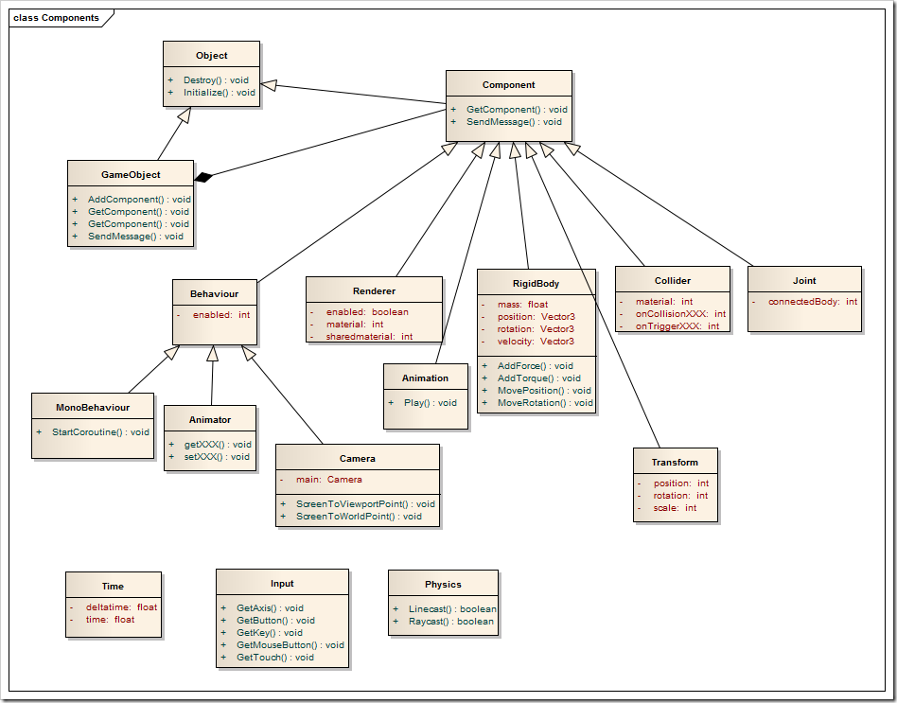

Unity favors an entity/component based design relationship in which the current system was established. Shown above is a class diagram of a typical GameObject that is simulated in the game environment. The GameObject itself inherits from a more generic Object. It is also composed of multiple Component objects. The Renderer object supplies the material that is used for the rendering engine. The RigidBody object contains information such as position, velocity and rotation which are used for trajectory calculations. The Collider object is used for collision detection. The rest of the objects on the diagram further add assistance to the GameObject such as connected components and behaviors.

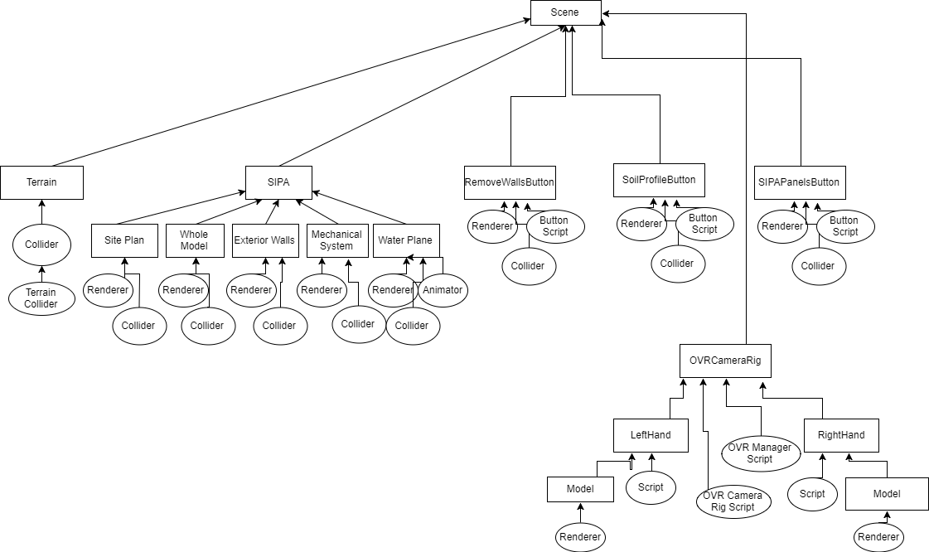

This UML diagram shows the relationship between the different GameObject on the scene and how they are related to each other. Here we can see that a scene has five mayor components (Terrain, SIPA, RemoveWallButton, SoilProfileButton, OVRCameraRig and SIPAPanelsButton). The Terrain object has the information for the topology construction. The SIPA object has the Site Plan, Whole Model, Exterior Walls, Mechanical System and Water Plane objects which all together make the SIPA building. The RemoveWallButton, SoilProfileButton and SIPAPanelsButton oversee the interactions with different parts of the model and experiences. Finally, The OVRCameraRig handles the coordination between the left and right controller. All the GameObject can be initialized or destroyed.

## System and Subsystem Decomposition

As you can see in the following image, the Learning with Virtual Reality 5.0 system was modeled between three different interfaces. The system was designed this way to be able to treat different types of objects the same way. As an example, we can see the Experiences interface being implemented LightChanges, RemoveWalls, InspectMechanics, SoilProfile and SIPAPanels. Since all the mentioned objects have naturally the same behavior it made sense to have them interfaced. Same concept was extended to the Controls and User Interface. There is also a OVRManager class to manage the headset display unit and the touch controls input.

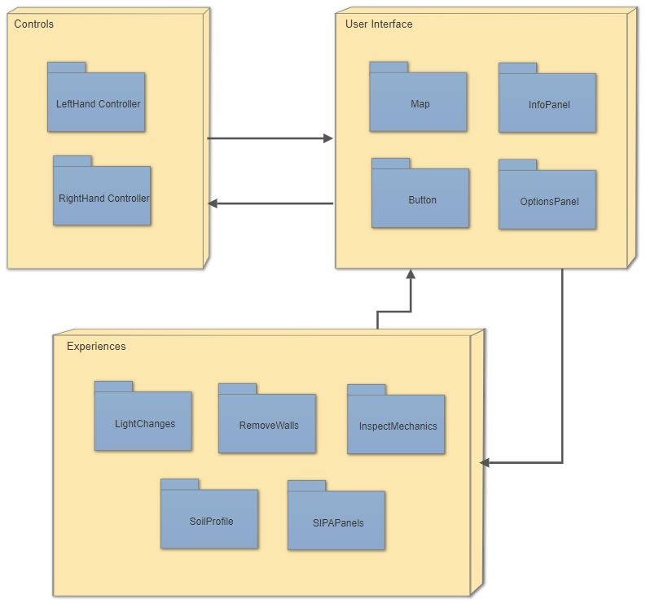

## Deployment Diagram

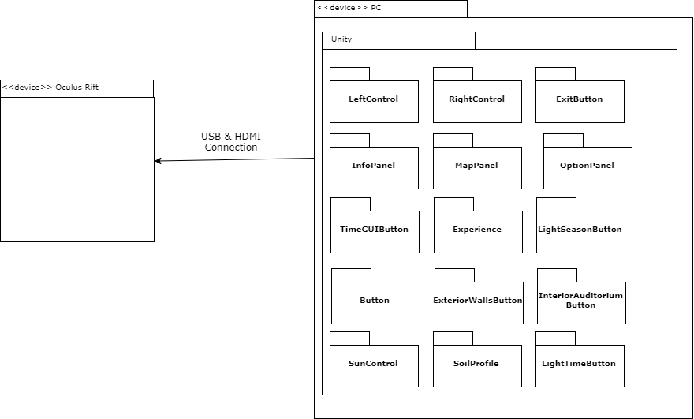

The deployment model for Learning with Virtual Reality 5.0 is simple. An executable file was created/generated from within Unity for the project. The executable file can run on a Windows PC device that has the Oculus Rift device attached via the USB & HDMI connection. The Oculus program will communicate with the Oculus Rift and Windows to execute the simulation and allow the user/student to interact with the model.

## Design Patterns

**Singleton**:

The singleton design pattern was used for the scripts since they are specific to each entity and the functions are detailed within the scripts.

**Composite**:

The composite design pattern was used for the Component object to treat the individual objects uniformly. This way a tree structure allows for a uniform composition.

**Command**:

The command design pattern was used for the Joint class as a command to join two GameObject together.

# System Validation

**Unit Tests**

**User Story #314 – Fix lighting inside SIPA building**

**Test Case 1: Sunny Day**

**Purpose:**

* To test that the light inside the SIPA 3D model is bright enough to see the textures and objects.

**Precondition:**

* The Learning with Virtual Reality 5.0 executable is running.
* The Oculus Rift VR headset is properly position on the user’s head.
* The left and right-hand controls are enabled.
* Oculus Rift sensors are enabled.

**Test Procedure:**

* User walks inside of SIPA building and looks around the hallways.

**Expected Result:**

* The user has enough visible light exposure to see the wall textures and corridors.

**Actual Results:**

* The user can see the wall textures and corridors.
  + Pass

**User Story #314 – Fix lighting inside SIPA building**

**Test Case 2: Rainy Day**

**Purpose:**

* To test that the light inside the SIPA 3D model is bright enough to see the textures and objects after walking in and out of the building while letting time pass by.

**Precondition:**

* The Learning with Virtual Reality 5.0 executable is running.
* The Oculus Rift VR headset is properly position on the user’s head.
* The left and right-hand controls are enabled.
* Oculus Rift sensors are enabled.

**Test Procedure:**

* User walks inside of SIPA building and looks around the hallways.
* User walks outside and change the time of day.
* User walks back inside of SIPA building and looks around the hallways.

**Expected Result:**

* The user has enough visible light exposure to see the wall textures and corridors.

**Actual Results:**

* The user can see the wall textures and corridors.
  + Pass

**User Story #315 – Fix path guidance texture**

**Test Case 1: Sunny Day**

**Purpose:**

* To test that the path guidance texture displayed on the Open World is visible.

**Precondition:**

* The Learning with Virtual Reality 5.0 executable is running.
* The Oculus Rift VR headset is properly position on the user’s head.
* The left and right-hand controls are enabled.
* Oculus Rift sensors are enabled.

**Test Procedure:**

* User walks around the SIPA building and looks for the highlighted guidance path in the Open World.

**Expected Result:**

* The user sees the yellow trail lines for the guidance path.

**Actual Results:**

* The user can see the yellow trail lines.
  + Pass

**User Story #315 – Fix path guidance texture**

**Test Case 1: Rainy Day**

**Purpose:**

* To test that the path guidance texture displayed on the Open World is visible after the user sees an animation.

**Precondition:**

* The Learning with Virtual Reality 5.0 executable is running.
* The Oculus Rift VR headset is properly position on the user’s head.
* The left and right-hand controls are enabled.
* Oculus Rift sensors are enabled.

**Test Procedure:**

* User plays an animation.
* User looks around the Open World searching for the yellow guidance lines.

**Expected Result:**

* The user sees the yellow trail lines for the guidance path.

**Actual Results:**

* The user can see the yellow trail lines.
  + Pass

**User Story #315 – Fix path guidance texture**

**Test Case 2: Rainy Day**

**Purpose:**

* To test that the path guidance texture displayed on the Open World is visible after the user interacts with a preprogrammed experience.

**Precondition:**

* The Learning with Virtual Reality 5.0 executable is running.
* The Oculus Rift VR headset is properly position on the user’s head.
* The left and right-hand controls are enabled.
* Oculus Rift sensors are enabled.

**Test Procedure:**

* User interacts with a preprogrammed experience.
* User looks around the Open World searching for the yellow guidance lines.

**Expected Result:**

* The user sees the yellow trail lines for the guidance path.

**Actual Results:**

* The user can see the yellow trail lines.
  + Pass

**User Story #315 – Fix path guidance texture**

**Test Case 3: Rainy Day**

**Purpose:**

* To test that the path guidance texture displayed on the Open World is visible after the user enters the SIPA building and walks back out.

**Precondition:**

* The Learning with Virtual Reality 5.0 executable is running.
* The Oculus Rift VR headset is properly position on the user’s head.
* The left and right-hand controls are enabled.
* Oculus Rift sensors are enabled.

**Test Procedure:**

* User walks inside of SIPA building.
* User walks outside of SIPA building.
* User looks around the Open World searching for the yellow guidance lines.

**Expected Result:**

* The user sees the yellow trail lines for the guidance path.

**Actual Results:**

* The user can see the yellow trail lines.
  + Pass

**User Story #316 – Correct the pivot point of the camera**

**Test Case 1: Sunny Day**

**Purpose:**

* To test that the camera rotates centric relative to the user’s head.

**Precondition:**

* The Learning with Virtual Reality 5.0 executable is running.
* The Oculus Rift VR headset is properly position on the user’s head.
* The left and right-hand controls are enabled.
* Oculus Rift sensors are enabled.

**Test Procedure:**

* User rotates his/her head without moving in any direction.

**Expected Result:**

* The camera rotates relative to the center point on the model head.

**Actual Results:**

* The camera rotated centric to the point on the model head.
  + Pass

**User Story #316 – Correct the pivot point of the camera**

**Test Case 1: Rainy Day**

**Purpose:**

* To test that the camera rotates centric relative to the user’s head even if the user elevates their z position.

**Precondition:**

* The Learning with Virtual Reality 5.0 executable is running.
* The Oculus Rift VR headset is properly position on the user’s head.
* The left and right-hand controls are enabled.
* Oculus Rift sensors are enabled.

**Test Procedure:**

* User increases/elevates their z position on the Open World.

**Expected Result:**

* The camera rotates relative to the center point on the model head.

**Actual Results:**

* The camera rotated centric to the point on the model head.
  + Pass

**User Story #317 – Get original SIPA 3D model**

**Test Case 1: Sunny Day**

**Purpose:**

* To test that the SIPA 3D model file matches visually with the real FIU SIPA building.

**Precondition:**

* 3D Studio Max is running.
* Load SIPA 3D file in 3D Studio Max

**Test Procedure:**

* Check visually to see if the file is the real FIU SIPA building.

**Expected Result:**

* The loaded model matches visually with the real FIU SIPA building.

**Actual Results:**

* The file matches with the real FIU SIPA building.
  + Pass

**User Story #317 – Get original SIPA 3D model**

**Test Case 1: Rainy Day**

**Purpose:**

* To test that the SIPA 3D model file matches visually with the real FIU SIPA building after optimizing.

**Precondition:**

* 3D Studio Max is running.
* Load SIPA 3D file in 3D Studio Max
* Optimize object model.
* Save optimized file.

**Test Procedure:**

* Check visually to see if the optimized file looks like the real FIU SIPA building.

**Expected Result:**

* The optimized file model matches visually with the real FIU SIPA building.

**Actual Results:**

* The file matches with the real FIU SIPA building.
  + Pass

**User Story #318 – Edit Light Experience button**

**Test Case 1: Sunny Day**

**Purpose:**

* To test that the Light Experience button shows up and displays information.

**Precondition:**

* The Learning with Virtual Reality 5.0 executable is running.
* The Oculus Rift VR headset is properly position on the user’s head.
* The left and right-hand controls are enabled.
* Oculus Rift sensors are enabled.

**Test Procedure:**

* Locate the Light Experience button.
* Activate it.

**Expected Result:**

* The Light Experience button shows the slider to simulate the different times of the day.

**Actual Results:**

* The Light Experience button showed the slider to simulate the different times of the day.
  + Pass

**User Story #318 – Edit Light Experience button**

**Test Case 1: Rainy Day**

**Purpose:**

* To test that the Light Experience button shows up and displays information even while inside the SIPA Building.

**Precondition:**

* The Learning with Virtual Reality 5.0 executable is running.
* The Oculus Rift VR headset is properly position on the user’s head.
* The left and right-hand controls are enabled.
* Oculus Rift sensors are enabled.

**Test Procedure:**

* Walk inside of the SIPA building.
* Locate the Light Experience button.
* Activate it.

**Expected Result:**

* The Light Experience button shows the slider to simulate the different times of the day.

**Actual Results:**

* The Light Experience button showed the slider to simulate the different times of the day.
  + Pass

**User Story #319 – Fix wall experience**

**Test Case 1: Sunny Day**

**Purpose:**

* To test that the Wall Experience hides the billboard and rotates the camera to the line of sight of the experience

**Precondition:**

* The Learning with Virtual Reality 5.0 executable is running.
* The Oculus Rift VR headset is properly position on the user’s head.
* The left and right-hand controls are enabled.
* Oculus Rift sensors are enabled.

**Test Procedure:**

* Locate the Wall Experience button.
* Activate it.

**Expected Result:**

* The billboard hides.
* Camera rotates to show the Wall Experience.

**Actual Results:**

* The billboard hides.
  + pass
* Camera rotates to show the Wall Experience.
  + pass

**User Story #319 – Fix wall experience**

**Test Case 1: Rainy Day**

**Purpose:**

* To test that the Wall Experience shows the billboard if the experience is prematurely terminated

**Precondition:**

* The Learning with Virtual Reality 5.0 executable is running.
* The Oculus Rift VR headset is properly position on the user’s head.
* The left and right-hand controls are enabled.
* Oculus Rift sensors are enabled.

**Test Procedure:**

* Locate the Wall Experience button.
* Activate it.
* Prematurely terminate the experience.

**Expected Result:**

* The billboard shows.

**Actual Results:**

* The billboard is shown.
  + Pass

**User Story #320 – Fix soil experience**

**Test Case 1: Sunny Day**

**Purpose:**

* To test that the Soil Experience button shows the soil during the animation in the Open World.

**Precondition:**

* The Learning with Virtual Reality 5.0 executable is running.
* The Oculus Rift VR headset is properly position on the user’s head.
* The left and right-hand controls are enabled.
* Oculus Rift sensors are enabled.

**Test Procedure:**

* Locate the Soil Experience button.
* Activate it.

**Expected Result:**

* Soil should be show.

**Actual Results:**

* Soil shows up.
  + pass

**User Story #320 – Fix soil experience**

**Test Case 1: Rainy Day**

**Purpose:**

* To test that the Soil Experience button hides the soil if the animation is prematurely terminated.

**Precondition:**

* The Learning with Virtual Reality 5.0 executable is running.
* The Oculus Rift VR headset is properly position on the user’s head.
* The left and right-hand controls are enabled.
* Oculus Rift sensors are enabled.

**Test Procedure:**

* Locate the Soil Experience button.
* Activate it.
* Prematurely terminate the experience.

**Expected Result:**

* Soil should be hidden.

**Actual Results:**

* Soil is hidden.
  + Pass

**User Story #323 – Add water collection animation**

**Test Case 1: Sunny Day**

**Purpose:**

* To test that the Water Collection animation is displayed when the Water Collection experience is started.

**Precondition:**

* The Learning with Virtual Reality 5.0 executable is running.
* The Oculus Rift VR headset is properly position on the user’s head.
* The left and right-hand controls are enabled.
* Oculus Rift sensors are enabled.

**Test Procedure:**

* Locate the Water Collection button.
* Activate it.

**Expected Result:**

* Water collection is displayed.
* Water collection animation begins.

**Actual Results:**

* Water collection is displayed.
  + pass
* Water collection animation begins
  + Pass

**User Story #323 – Add water collection animation**

**Test Case 1: Rainy Day**

**Purpose:**

* To test that the Water Collection animation hidden if the experience is prematurely terminated.

**Precondition:**

* The Learning with Virtual Reality 5.0 executable is running.
* The Oculus Rift VR headset is properly position on the user’s head.
* The left and right-hand controls are enabled.
* Oculus Rift sensors are enabled.

**Test Procedure:**

* Locate the Water Collection button.
* Activate it.
* Prematurely terminate the experience.

**Expected Result:**

* Water Collection is hidden.

**Actual Results:**

* Water Collection is hidden.
  + Pass

**User Story #324 – Remove wall to see elevator**

**Test Case 1: Sunny Day**

**Purpose:**

* To test that the wall in front of the elevator are hidden and thus showing the elevator inside the SIPA building.

**Precondition:**

* The Learning with Virtual Reality 5.0 executable is running.
* The Oculus Rift VR headset is properly position on the user’s head.
* The left and right-hand controls are enabled.
* Oculus Rift sensors are enabled.

**Test Procedure:**

* Locate the elevator inside the SIPA building.
* Click view elevator.

**Expected Result:**

* Elevator is shown.

**Actual Results:**

* The elevator is shown.
  + pass

**User Story #324 – Remove wall to see elevator**

**Test Case 1: Rainy Day**

**Purpose:**

* To test that the wall in front of the elevator is not hidden if the user doesn’t have a line of sight to the elevator.

**Precondition:**

* The Learning with Virtual Reality 5.0 executable is running.
* The Oculus Rift VR headset is properly position on the user’s head.
* The left and right-hand controls are enabled.
* Oculus Rift sensors are enabled.

**Test Procedure:**

* Locate the elevator inside the SIPA building.
* Look in the opposite direction.

**Expected Result:**

* View elevator button is not visible.

**Actual Results:**

* The elevator button is not visible.
  + pass

**User Story #325 – Add wind animation**

**Test Case 1: Sunny Day**

**Purpose:**

* To test that the wind animation begins when the user clicks the Wind Experience.

**Precondition:**

* The Learning with Virtual Reality 5.0 executable is running.
* The Oculus Rift VR headset is properly position on the user’s head.
* The left and right-hand controls are enabled.
* Oculus Rift sensors are enabled.

**Test Procedure:**

* Locate Wind Experience button.
* Click it.

**Expected Result:**

* Wind animation begins and is displayed on the VR headset.

**Actual Results:**

* Wind animation begins and is displayed on the VR headset.
  + pass

**User Story #325 – Add wind animation**

**Test Case 1: Rainy Day**

**Purpose:**

* To test that the wind animation keeps playing after the user moves around the Open World.

**Precondition:**

* The Learning with Virtual Reality 5.0 executable is running.
* The Oculus Rift VR headset is properly position on the user’s head.
* The left and right-hand controls are enabled.
* Oculus Rift sensors are enabled.

**Test Procedure:**

* Locate Wind Experience button.
* Click it.
* Move around.

**Expected Result:**

* Wind animation continues playing.

**Actual Results:**

* Wind animation continued playing.
  + pass

**User Story #329 – Add popup info**

**Test Case 1: Sunny Day**

**Purpose:**

* To test that the popup info displays when the user interacts with the objects.

**Precondition:**

* The Learning with Virtual Reality 5.0 executable is running.
* The Oculus Rift VR headset is properly position on the user’s head.
* The left and right-hand controls are enabled.
* Oculus Rift sensors are enabled.

**Test Procedure:**

* Locate an object connected to a popup.
* Look at it.

**Expected Result:**

* Information shows when looking at the structure.

**Actual Results:**

* Information shows when looking at the structure.
  + pass

**User Story #329 – Add popup info**

**Test Case 1: Rainy Day**

**Purpose:**

* To test that the popup info displays doesn’t display anything when the Line of Sight is broken.

**Precondition:**

* The Learning with Virtual Reality 5.0 executable is running.
* The Oculus Rift VR headset is properly position on the user’s head.
* The left and right-hand controls are enabled.
* Oculus Rift sensors are enabled.

**Test Procedure:**

* Locate an object connected to a popup.
* Look at it.
* Turn 180 degrees.

**Expected Result:**

* Information for the object is hidden.

**Actual Results:**

* Information for the object is hidden.
  + pass

**User Story #329 – Change pointer model**

**Test Case 1: Sunny Day**

**Purpose:**

* To test that the new pointer model loads.

**Precondition:**

* The Learning with Virtual Reality 5.0 executable is running.
* The Oculus Rift VR headset is properly position on the user’s head.
* The left and right-hand controls are enabled.
* Oculus Rift sensors are enabled.

**Test Procedure:**

* Begin the simulation.

**Expected Result:**

* New pointer model is visible.

**Actual Results:**

* New pointer model is visible.
  + pass

**User Story #329 – Change pointer model**

**Test Case 1: Rainy Day**

**Purpose:**

* To test that the new pointer model loads after simulation restart.

**Precondition:**

* The Learning with Virtual Reality 5.0 executable is running.
* The Oculus Rift VR headset is properly position on the user’s head.
* The left and right-hand controls are enabled.
* Oculus Rift sensors are enabled.

**Test Procedure:**

* Begin the simulation.
* Stop and restart simulation

**Expected Result:**

* New pointer model is visible.

**Actual Results:**

* New pointer model is visible.
  + pass

# 

# Glossary

**Agile**: Agile software development is a set of principles for software development in which requirements and solutions evolve through collaboration between self-organizing, cross-functional teams. It promotes adaptive planning, evolutionary development, early delivery, and continuous improvement, and it encourages rapid and flexible response to change.

**C#**: Object-oriented programming language used to develop in Unity. It is a multi-paradigm programming language encompassing strong typing, imperative, declarative, functional, generic, object-oriented, and component-oriented programming disciplines. It was developed by Microsoft within its.NET initiative and later approved as a standard by Ecma and ISO. C# is one of the programming languages designed for the Common Language Infrastructure.

**Experience**: Learning animations in the Open World space.

**IDE**: Integrated Development Environment.

**Immersion**: Deep mental involvement.

**Mingle**: An Agile project management application from ThoughtWorks Studios for teams that need to make real-time decisions using real-time data. Mingle provides project intelligence and supports all team activity.

**Oculus Rift**: a photographic recording of a light field, rather than of an image formed by a lens, and it is used to display a fully three-dimensional image of the holographed subject.

**SIPA Building**: School of International and Public Affairs building in FIU.

**Unity**: A cross-platform game engine developed by Unity Technologies and used to develop video games for PC, consoles, mobile devices and websites.

**Virtual Reality**: Virtual reality or virtual realities (VR), also known as immersive multimedia or computer-simulated reality, is a computer technology that replicates an environment, real or imagined, and simulates a user's physical presence that environment in a way that allows the user to interact with it.

**World Space**: An open world that is explorable by the player.

# Appendix

## Appendix A - UML Diagrams

## Use Case Diagram

## 

## Use case Diagram: Movement

## Class Diagram

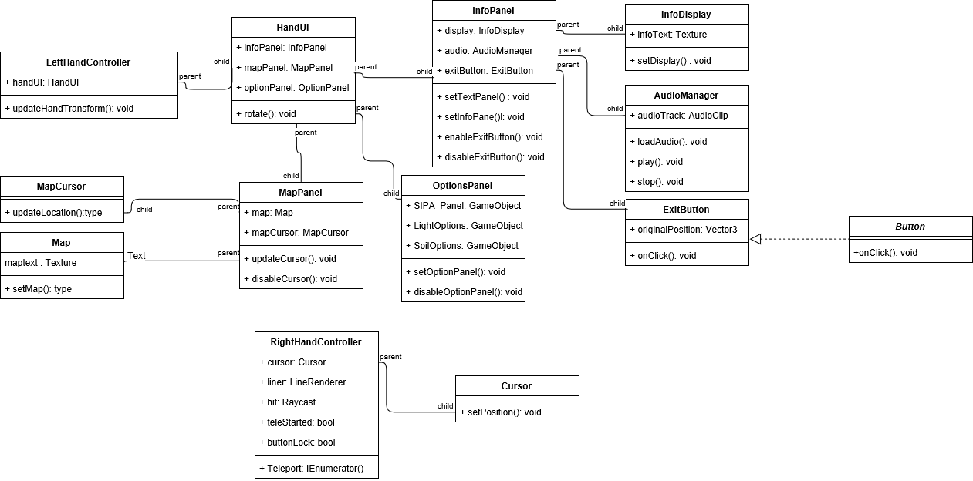

## Full Class Diagram

## Sequence Diagram

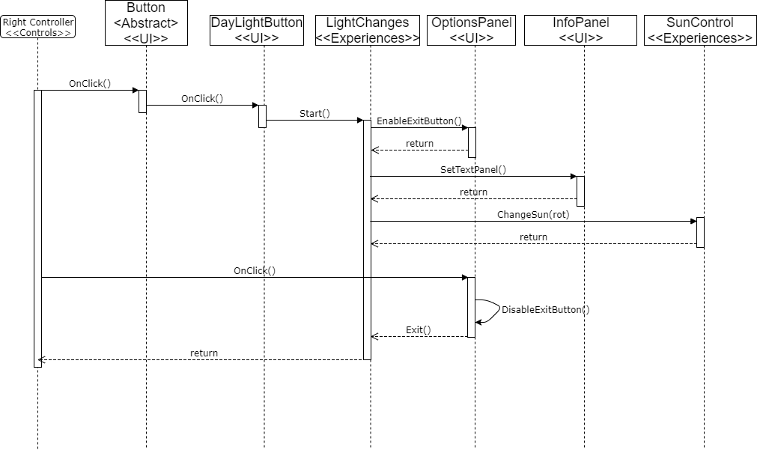

**Daylight Experience Sequence Diagram**

## 

## Appendix B - User Interface Design

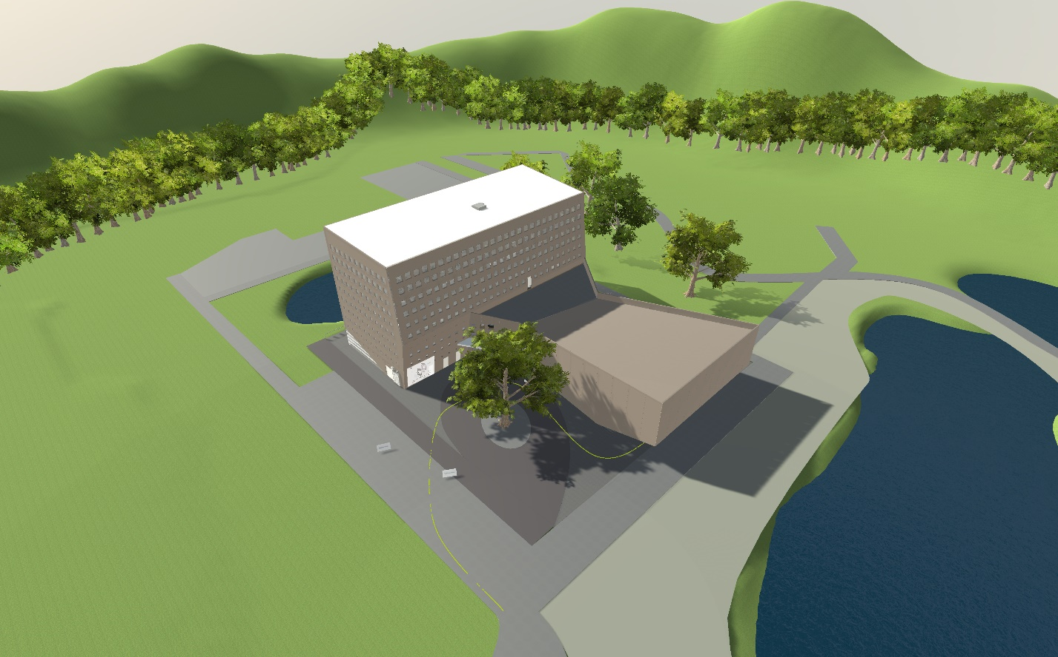

View of the SIPA building in the Open World.

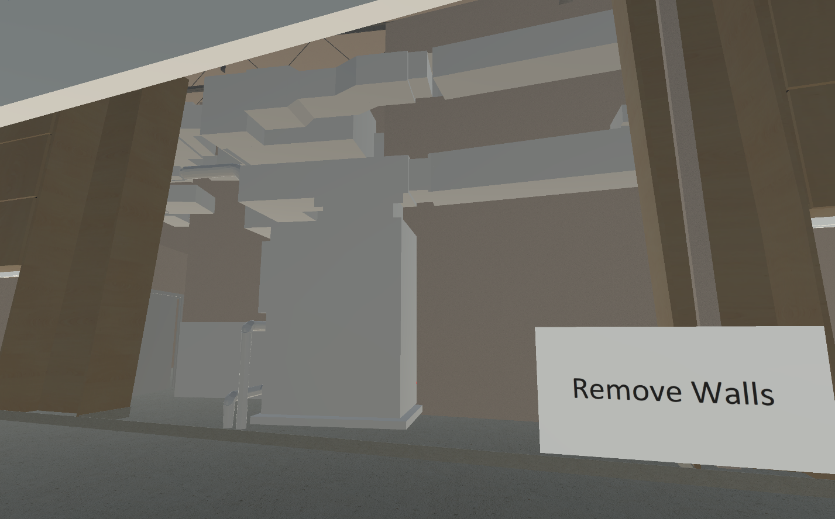

This is the Remove Walls experience. It shows the internal mechanics that are hidden by the building walls.

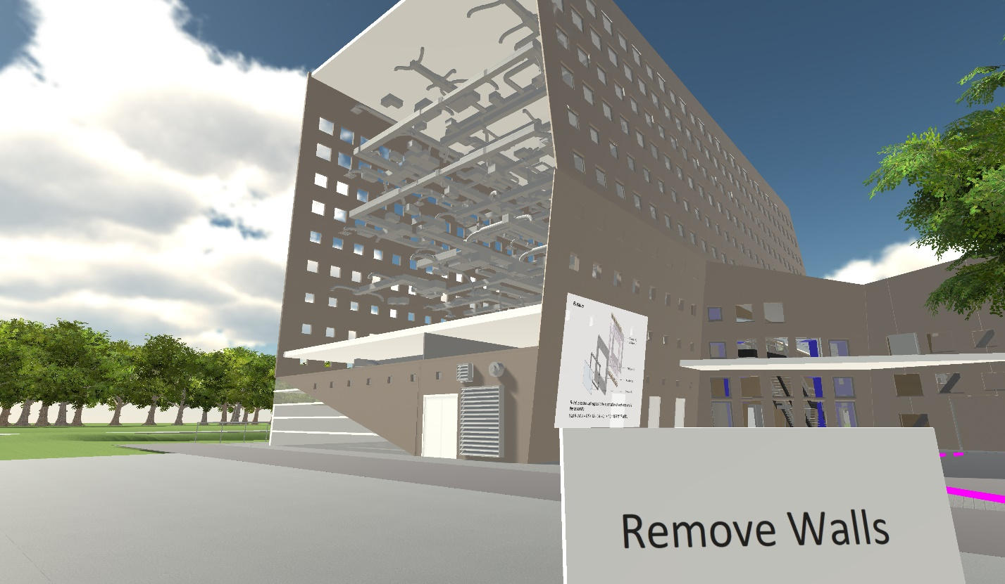

This is the Remove Walls experience from outside of the SIPA building. It shows the internal mechanics that are hidden by the building walls.

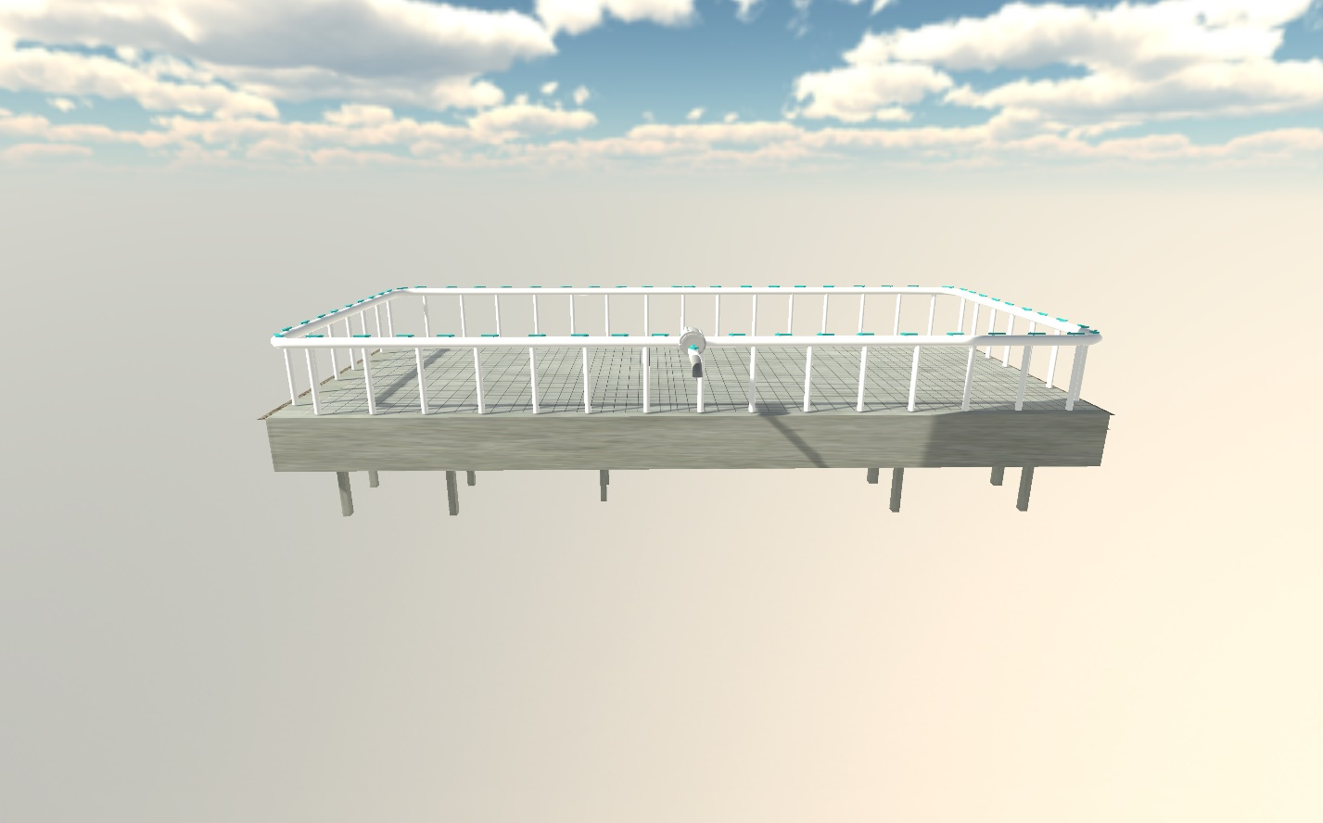

Image depicting part of the Soil Experience animation.

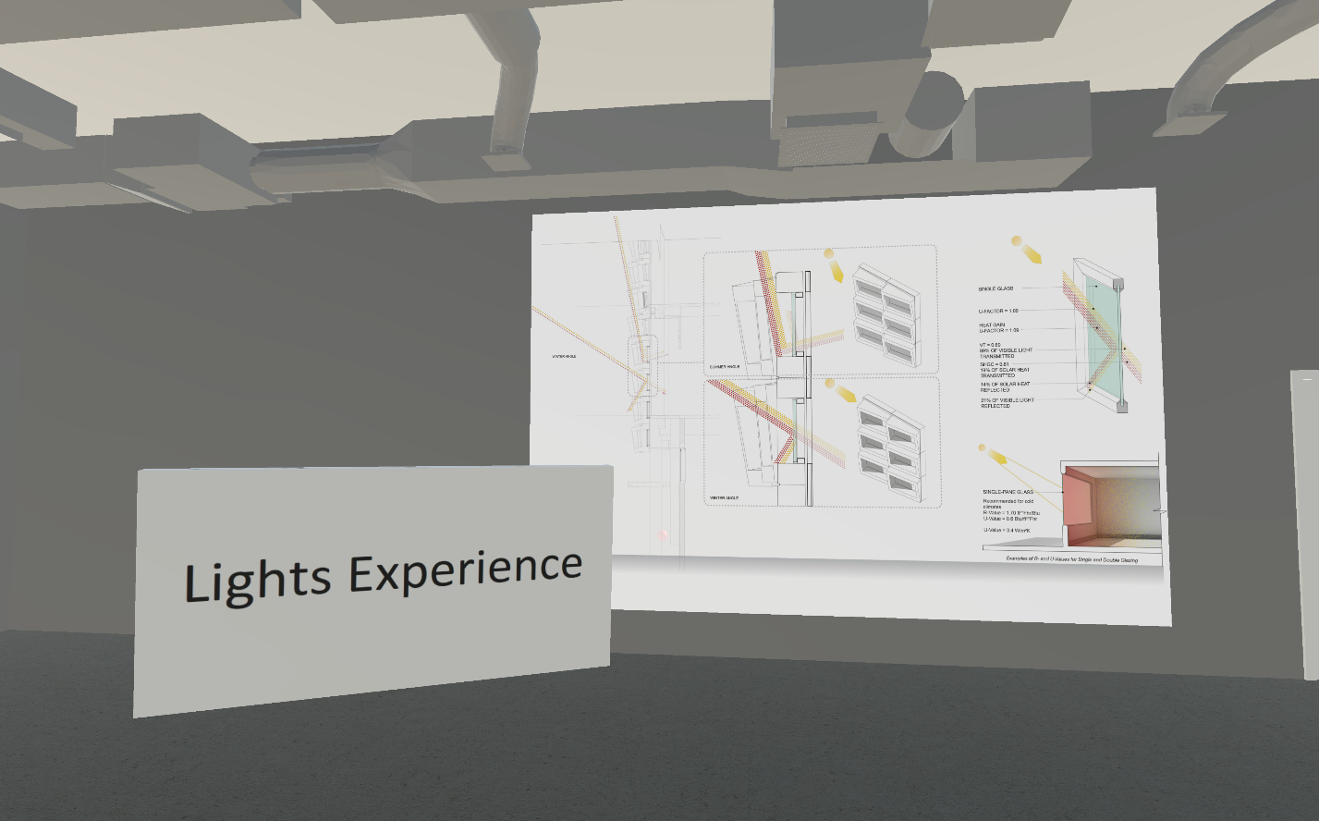

Lights Experience user interface to change and simulate the day time.

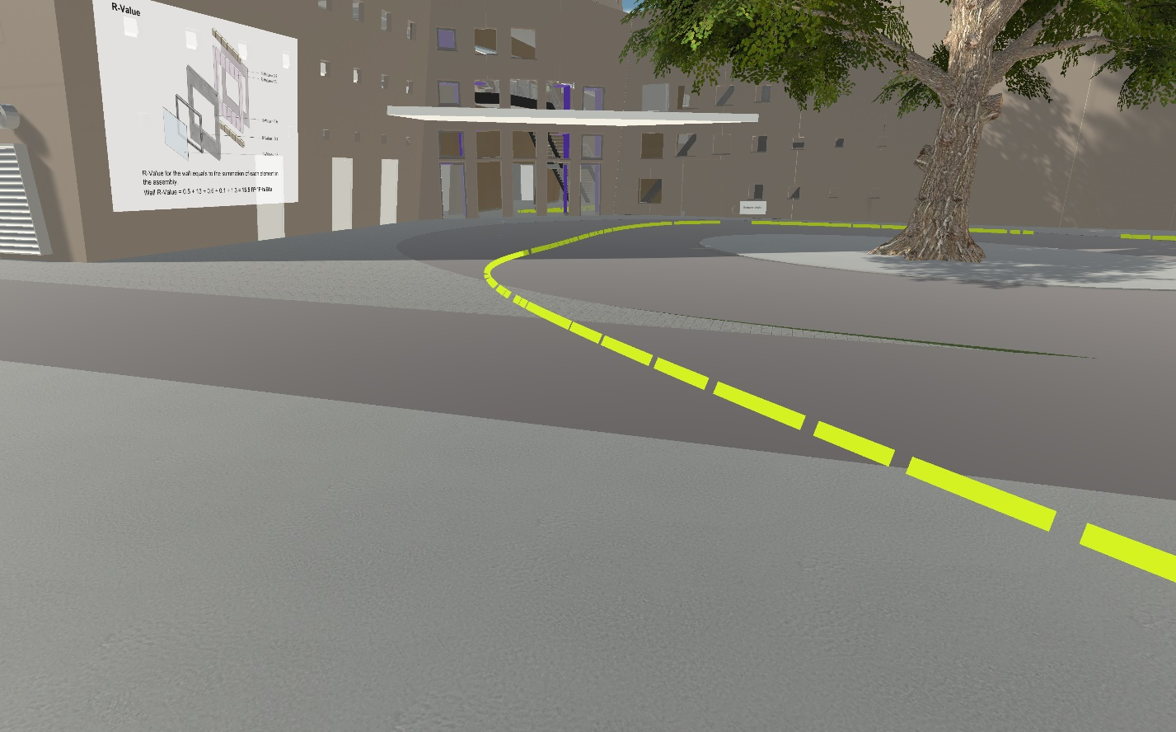

Walkthrough particle guidance around the building in the simulation.

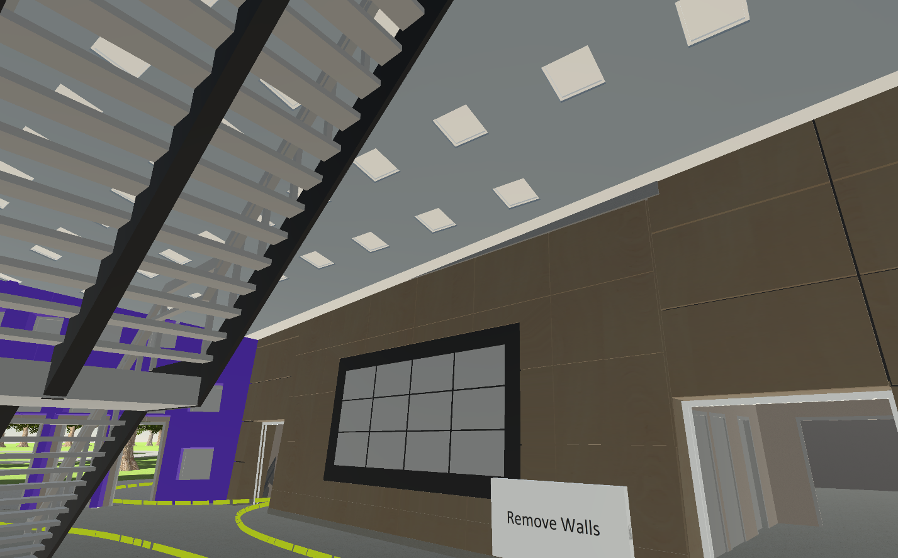

Inside view of SIPA building with correct ambient lighting to show textures and have visibility.

## Appendix C - Sprint Review Reports

### Sprint 3 Review

Attendees: Jerry, Roger

Start time: 1:00

End time: 2:30

After a show and tell presentation, the implementation of the following user stories was accepted by the product owners: All.

* [learning_with_virtual_reality/#323] Add water collection animation
* [learning_with_virtual_reality/#314] Fix lighting inside SIPA building
* [learning_with_virtual_reality/#316] Correct the pivot point of the camera
* [learning_with_virtual_reality/#320] Fix soil experience

The following ones were rejected and moved back to the product backlog to be assigned to a future sprint at a future Sprint Planning meeting.

* [learning_with_virtual_reality/#319] Fix wall experience
* [learning_with_virtual_reality/#325] Add wind animation
* [learning_with_virtual_reality/#318] Edit Light Experience button

### Sprint 4 Review

Attendees: Jerry, Roger

Start time: 1:00

End time: 2:30

After a show and tell presentation, the implementation of the following user stories was accepted by the product owners: All.

* [learning_with_virtual_reality/#315] Fix path guideline texture
* [learning_with_virtual_reality/#324] Remove wall to see elevator
* [learning_with_virtual_reality/#318] Edit Light Experience button
* [learning_with_virtual_reality/#316] Correct the pivot point of the camera

The following ones were rejected and moved back to the product backlog to be assigned to a future sprint at a future Sprint Planning meeting.

* [learning_with_virtual_reality/#323] Add water collection animation
* [learning_with_virtual_reality/#320] Fix soil experience

### Sprint 5 Review

Attendees: Jerry, Roger

Start time: 1:00

End time: 2:30

After a show and tell presentation, the implementation of the following user stories was accepted by the product owners: All.

* [learning_with_virtual_reality/#314] Fix lighting inside SIPA building
* [learning_with_virtual_reality/#323] Add water collection animation
* [learning_with_virtual_reality/#325] Add wind animation

The following ones were rejected and moved back to the product backlog to be assigned to a future sprint at a future Sprint Planning meeting.

* None

### Sprint 6 Review

Attendees: Jerry, Roger

Start time: 1:00

End time: 2:30

After a show and tell presentation, the implementation of the following user stories was accepted by the product owners: All.

* [learning_with_virtual_reality /#325] Add wind animation
* [learning_with_virtual_reality /#329] AddPopupInfo
* [learning_with_virtual_reality /#330] Change Pointer Model

The following ones were rejected and moved back to the product backlog to be assigned to a future sprint at a future Sprint Planning meeting.

* None

## Appendix D - User Manuals, Installation/Maintenance Document, Shortcomings/Wishlist Document and other documents

**User Manual**

1. The user will start in the Open World start location.
2. To move around the world the user must do the following:
   1. Press “A” on the right Oculus touch controller.
   2. Point the right controller to a desired location.
      1. A red line with a dot will appear in the direction of pointer.
   3. Release “A” to teleport to desired location.
   4. User should be in correct location
3. To select a desired panel in the hub:
   1. The user must push up or down on the left Oculus touch controller.
   2. The hub will rotate.
   3. Stop when the desired panel is visible.
4. To click on a button on the Open World:
   1. Point the right Oculus touch controller to the desired button.
   2. Red point should be aiming at the button.
   3. Press the black trigger on the back of the right Oculus controller.
   4. The button will activate.
5. To see different experiences:
   1. User must walk around the Open World SIPA building.
   2. Locate any of the preprogrammed experiences available.
   3. Click on them to view the animation.

**Installation & Maintenance**

To run the application, proceed with the following installation steps:

1. Use a computer with Windows 8.1 and above Operating System.
   1. Computer must meet the following minimum hardware specifications
      1. Processor: Intel i7-7500U 2.7 GHz.
      2. Graphics card: GeForce 940MX
      3. RAM: 12GB
      4. Video output: HDMI 1.3
      5. USB: One USB 3.0 and two USB 2.0
2. Acquire Oculus Rift system, which contains:
   1. Oculus Rift Head Mounted Display
   2. Touch Controllers (Left and Right hand)
   3. Two Oculus sensors at a minimum.
3. Connect Oculus Rift system to Computer:
   1. Oculus rift must be connected to a HDMI 3.1 port connected to the Graphics card and a USB 3.0 port.
   2. Each Oculus sensor must be connected to an individual USB 3.0 port.
4. Install Oculus Software from Oculus site:
   1. https://www.oculus.com/setup/
5. Download Project from GitHub to a desirable folder location.
   1. https://github.com/FIU-SCIS-Senior-Projects/Learning-with-Virtual-Augmented-Reality-5.0
   2. Open Unity Scene file “Main”
6. Put Oculus Rift on with touch controllers and press play on Unity.

**Short Comings and Wishlist**

There were a couple of user stories that we didn’t have time to finish. The following user stories will add user experience and provide a richer experience:

* **User Story #313 – Add anti-aliasing to model**

**As a developer, I want to** add anti-aliasing so that the SIPA building model renders nicer.

* Acceptance Criteria:

1. The SIPA building model edges are smooth.
2. The SIPA building model transitions and rotates seamless.

* **User Story #321 – Check animations available**

**As a developer, I want to** check all animations available so that I can assess their functionality.

* Acceptance Criteria:

1. List all animations currently in the project that are working.

* **User Story #322 – Reduce poly-count on windows**

**As a developer, I want to** reduce the poly-count on the windows so that the model can render faster.

* Acceptance Criteria:

1. Poly-count reduced.

* **User Story #328 – Replace SIPA 3D model windows**

**As a developer, I want to** replace the old high poly windows with new lower poly ones.

* Acceptance Criteria:

1. Old windows are replaced with new ones.

It would also be nice to re-introduce Augmented Reality to the project so that the users can go to the real SIPA building and interact with some of the Virtual Experiences.

We recommend that the future developers export the original model in a smaller format that way the Unity Game engine has an easier time to display the model.

**IDE (Integrated Development Environment)**

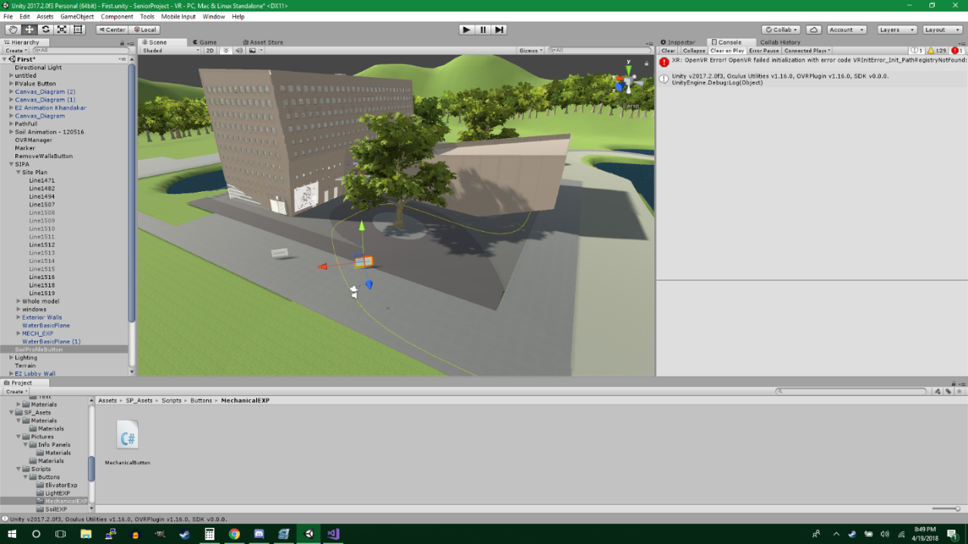

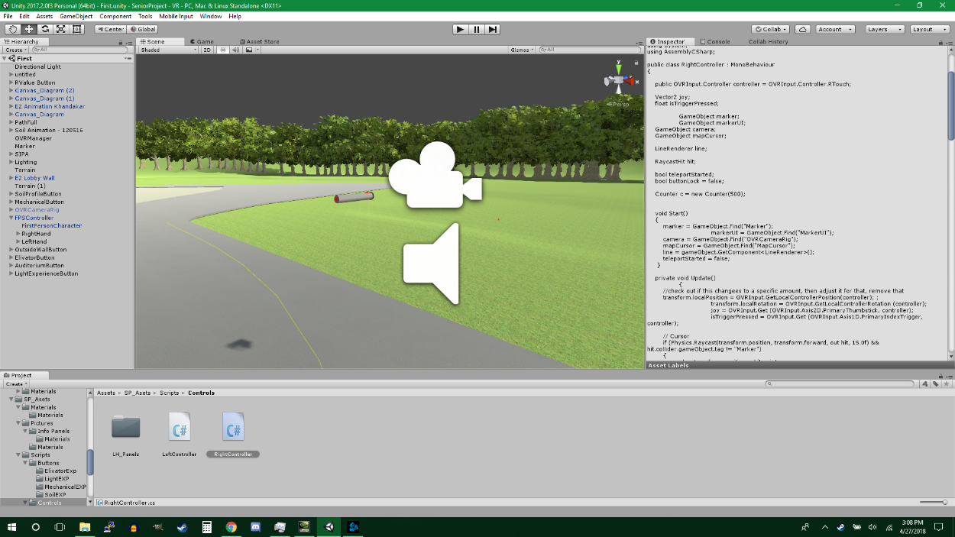

# References

* https://www.oculus.com/rift/
  + Oculus Rift Official Homepage
* https://developer.oculus.com/
  + Oculus Rift development homepage.
* https://developer.oculus.com/develop/
  + Oculus Rift documentation page.
* https://unity3d.com/
  + Unity home page.
* https://unity3d.com/learn/tutorials/
  + Unity beginner tutorials.
* http://wiki.unity3d.com/index.php/Main_Page/
  + Unity wiki to gather information.
* https://unity3d.com/learn/tutorials/topics/production/unity-test-tools/
  + Unity test tool tutorials.
* https://cloud.smartdraw.com/
  + Tool to draw UML diagrams.
* https://creately.com/
  + Tool to draw UML diagrams
* https://github.com/FIU-SCIS-Senior-Projects/Learning-with-Augmented-Reality-4.0/
  + The previous team who worked on this project. Their documentation was very useful.